Free school uniform initiative: guidance notes for nominating organisations (2024)
What is the free school uniform initiative?
The Life House’s free school uniform initiative has been running since 2010 and is now in its 14th year. The initiative aims to provide uniforms to families in need in our area of South Birmingham, enabling children and young people to start the school year in a brand-new school uniform, paid for by our generous donors! Professional agencies and schools may nominate families that they have identified as suitable beneficiaries.
The free school uniform initiative for 2024 launches on 8th April, and we are now accepting nominations. We hope that this initiative will benefit some of the less advantaged families with which you work. The Life House’s free school uniform initiative is not available throughout the year. This year’s deadline for nominations is Friday 24th May.
What uniform items might we provide?
Each eligible child included on a successful nomination will receive from the Life House new school uniforms, including:
one pair of trousers or a skirt
two shirts, two blouses or two polo shirts
a sweatshirt, cardigan or ‘v’-necked jumper
We will also endeavour to provide a blazer and tie to children who are about to start at a new secondary school, subject to resources.
Please note that the Life House does not provide footwear or pe kit.
Who can nominate a family?
The Life House is not able to accept nominations directly from parents or other family members. Each family must be nominated by an unrelated representative of a suitable organisation, who knows the family in a professional capacity. If you are not sure whether your organisation may submit a nomination, please ask!
What are our eligibility criteria?
The Life House will consider purchasing free school uniforms for eligible families only. The eligibility criteria for consideration for free school uniforms are as follows:
- Organisations must have the consent of a parent or legal (not informal) guardian before submitting a nomination.
- Each nominated family must find it difficult to obtain suitable uniforms for their children (e.g. financial hardship, home circumstances that make it difficult to purchase uniforms, etc.).
- Families must have at least one child who is either:
Our target area is currently defined as lying within a two-and-a-half mile radius of B29 6pb, excluding any areas outside Birmingham’s city limits.
  - about to enter years 1 – 11 (inclusive), at a state-funded school in Birmingham within our target area.
  - about to enter years 12 – 13 of a fully state-funded programme of study in Birmingham within our target area, provided that the wearing of a uniform is essential for their programme of study.
If you are not sure whether a school is in this area, please ask us!
- 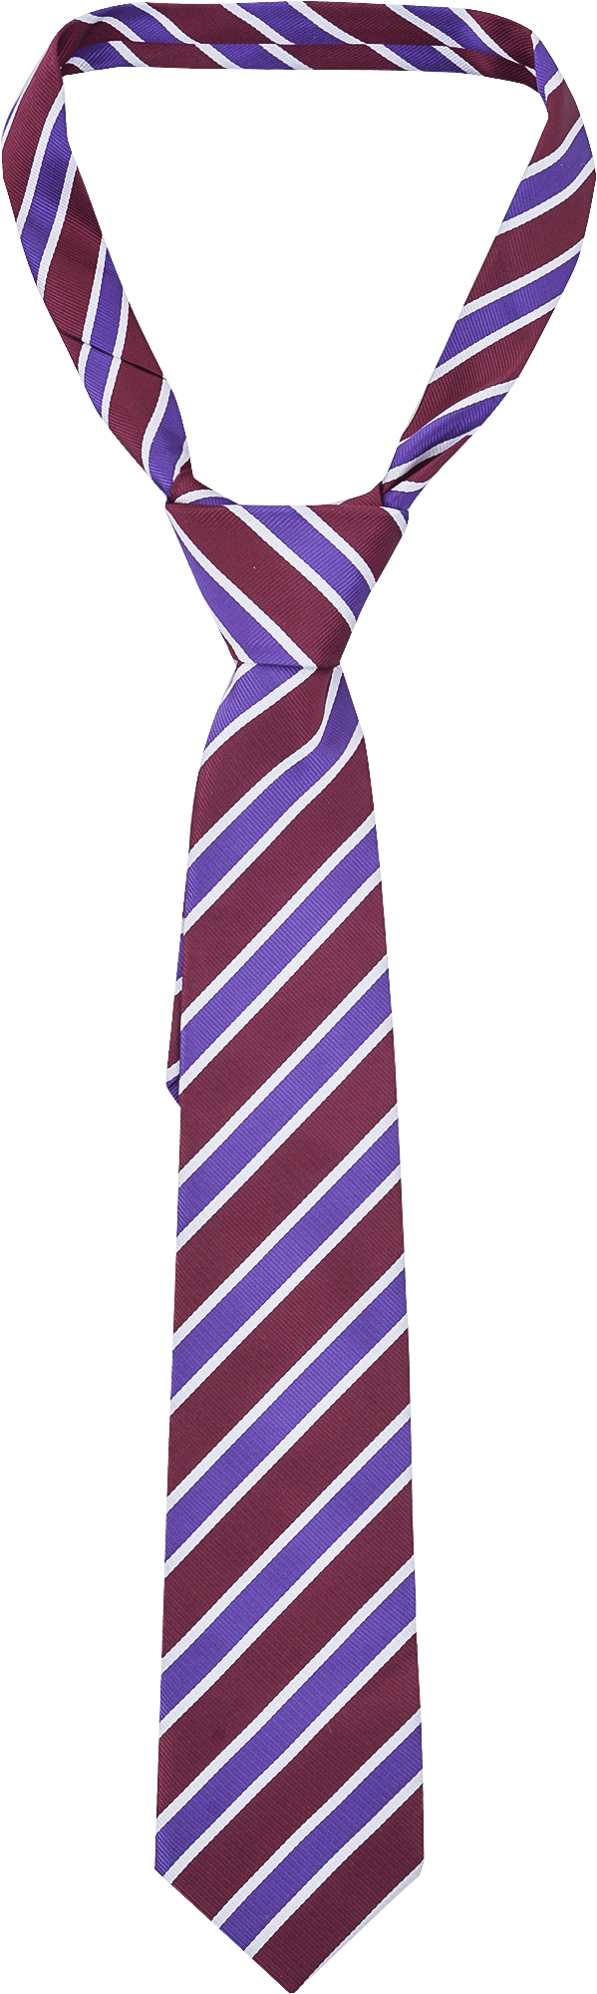Nominations must be received by the deadline, Friday 24th May. We cannot consider any received after this date.
- Where a local authority is known to have a statutory obligation to provide assistance with uniform to a child (e.g. under section 17 of the Children Act 1989 etc.), that child is not eligible for a school uniform from the Life House’s free school uniform initiative. Similarly, if the nominating organisation has an obligation to provide uniform to a child, that child is not eligible.
If you are unsure whether a family is eligible, please ask us! If the family that you wish to nominate does not meet these eligibility criteria for the annual free school uniform initiative, please do not nominate it. This will save embarrassment and disappointment.
May I include additional children in a nomination?
The Life House works with whole families rather than just individual children, so you’re welcome to include additional children, even if they attend different schools. Additional children may be included on the same nomination provided that they are about to attend years 1 – 11 (inclusive) at a state-funded Birmingham school, or are about to attend a year 12 – 13 programme of study in Birmingham that requires a uniform and is fully state-funded. Additional children may attend a school or programme outside our target area, provided that it is based in Birmingham. Additional children must belong to the same family, i.e. have the same parent or legal (not informal) guardian as the first child.
How do I fill in the ‘reasons for nomination’?
Please complete this section with care to maximise your nominations’ chances of success. We ask you why you are nominating each family for two reasons:
- Demand for uniforms is likely to exceed our capacity to provide them, so we decide which eligible nominations are successful solely on the basis of need. Points are assigned based on the information you provide in the nomination form. This is why it is important that you complete your ‘reasons for nomination’ carefully!
- We use the information that you give us to decide what other Life House services might help the family. We often find that we are able to help in ways that the nominating organisation cannot.
Weightings are assigned to particular circumstances, and points are awarded in the following areas:
acute family stress
abuse
care considerations
medical considerations
low income
unavoidable significant financial outlay
The Life House pays especial attention to circumstances affecting the nuclear family during the academic year 2023 - 2024. Please be specific with dates so that we know whether the circumstances in question are relevant to the time period on which we focus. Additionally, avoid vague phrases like ‘cashflow problems’, ‘trouble with benefits’ and ‘has had health problems’, which are not specific enough to count towards our needs assessment. We hope that you will discuss and agree with each parent or guardian the degree of detail that they are happy to share with us. Our Data protection & confidentiality policy is available on request and should reässure both you and the parents/guardians.
What happens next?
Not all nominations are successful, so please do not lead parents / guardians to believe that they have guaranteed uniforms: they should assume that they must budget for uniforms unless we tell them otherwise in June. We do not communicate with families directly until we have decided to whom we shall offer uniforms.
We will acknowledge receipt of your nominations within two weeks of receiving them. We might be in touch with further questions if necessary. Rather than use a full name, we’ll refer to your nomination using a code consisting of the first three letters of the parent’s/guardian’s surname and four digits, e.g. a nomination for Joanne Bloggs’s family may have the code BLO2400.
Once we have checked nominations for eligibility, assessed the needs of the nominated families, and verified the assessor’s work, we will notify you of the results of your nominations in mid-June. If a nominating organisation is dissatisfied with a result, it may request that the Life House review its decision. Any reviews will be conducted by a member of the Life House’s staff who did not participate in the original assessment. The reviewer’s decision is final.
We’ll also make contact with successful families to offer to buy their uniforms and to request their uniform specifications. We will not make contact with families whose nominations were unsuccessful.
We will invite successful families to collect their uniforms at an event on 8th August 2024, where we will be able to discuss any further ways in which the Life House might support them. Families may opt in to these additional forms of support.

